
Nelson Primary School
Inspiring Ambition, Achieving Success
Weekly Home Learning Tasks
Key Stage 2 Year 5 10.2.20
Homework books must be in school on Monday and will be returned on Tuesday.
Reading - Please read aloud to an adult every day. Write a summary of what you have read or discuss the story with an adult. Please record in your reading record book the pages that you have read each day. Remember to bring your book and reading record to school every day. Please visit Nelson School Library for your reading books.
Maths – Complete mathletics homework. Log on or download the app www.mathletics.co.uk to complete the set homework activities. https://login.mathletics.com/ Practise your times tables for our weekly quiz. Once you have completed Mathletics an additional websites to use is www.timestables.co.uk.
Grammar – Log on to purplemash and complete your set grammar homework task. https://www.purplemash.com/sch/nelson-e6
Spelling
- You must ensure you know the meaning of the word. -use a dictionary to help you if you are unsure.
- Write a sentence for some of the words. You can include more than one word in a sentence as long as it makes sense and shows that you understand the word.
- Practise and study all of the spelling words ready for the Weekly Spelling Test. To help you learn, every day you could draw a table like below to help you practise.
- Use your spelling menu to help you Practise your spellings. You can pick whatever activities you like to help you learn all the words.
Look Say Cover Write Check
 | Tuesday | Wednesday | Thursday | Friday | Saturday | Sunday
sacrifice
secretary
shoulder
signature
sincere
sincerely
soldier
stomach
sufficient
suggest
knuckle
ceiling
receipt
inefficient
proficient
sought
drought
admiration
considerable
perceive
Comprehension
Read the text, ‘Listen to the Moon’ by Michael Morpurgo, and complete the comprehension questions in your homework book.
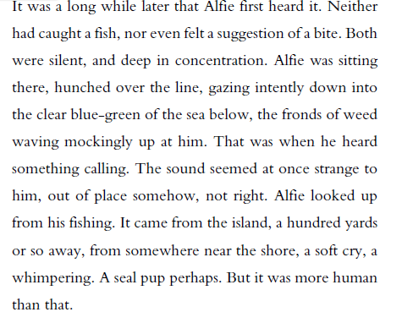

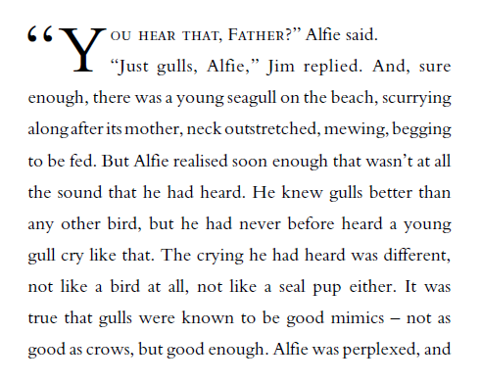

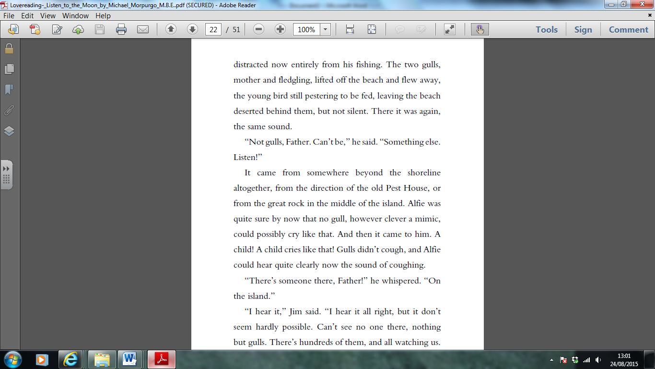

Retrieving Information
- Use a dictionary to find the definition of:
- fronds
- intently
- perplexed
- Find and copy a word that shows the noise that Alfie hears is a sad one.
- What is the relationship between Jim and Alfie?
- How do you know that Alfie spends a lot a time out on the coast?
- Have Alfie and Jim just arrived or have they been out for a while? How do you know?
- Why do you think that Alfie whispers to his father at the end of the extract?
- Why do you think the writer has started with the line, “It was a long while later that Alfie first heard it.”? What mood does this create?
- Why do you think the author describes the weed as “waving mockingly”?
- Why might Jim think that is not possible for a child to be on the island?

Grammar – complete these questions on the sheet.
Q1. Rewrite the verbs in the boxes to complete the sentences with the correct choice of tense.
The visitors left after they their coffee.
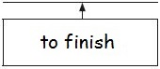
Jo usually up early on Saturday morning and goes swimming before breakfast.
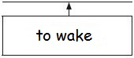 1 mark
Q2. Label each of the clauses in the sentence below as either main (M) or subordinate (S).
When the bell rang, we dashed into the playground and we started a game of football.
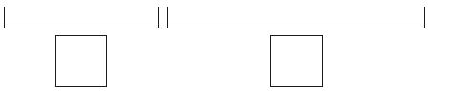1 mark
Q3. Circle the conjunction in each sentence.
We like to eat popcorn when we go to the cinema.
Although my sister likes salted popcorn, I prefer sweet popcorn.
My brother doesn’t like popcorn at all, so he buys sweets instead
1 mark
Q4. Which two sentences contain a preposition? | Tick two.
He walked really quickly. | 
The horse munched his hay happily.
She ran around the games field.
The old man walked past the door.
1 mark
Q5. Insert a pair of brackets in the correct place in the sentence below.
The highest mountain in Great Britain is Ben Nevis 1,344 metres in Scotland. 1 mark

Q6. Complete the sentence below with the simple past tense of the verbs in the boxes.
I netball last weekend, but I only
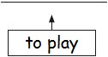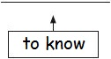
where the match the day before.
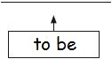
1 mark
Q7. Which one prefix can be added to all three words below to make their antonyms? Write the prefix in the box.
secure
active 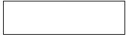
complete 1 mark

Q8. Circle the two words that are synonyms in the passage below.
The café serves delicious snacks and cakes until noon.
After midday, you can also order hot lunches, sandwiches or soup.
1 mark
Q9. Insert two hyphens in the correct places in the sentence below.
The children have been busy cooking some healthy sugar free snacks and learning some well known traditional songs for visitors to enjoy.
1 mark
Q10. Rewrite the sentence below in the active. Remember to punctuate your answer correctly.
The vital clues were discovered by the detective.
___________________________________________________________________ 1 mark

