THE LITTLE MERMAID

Once upon a time, there was a little mermaid named Ariel. She was the youngest daughter of the king of the sea, King Triton, but she was always dreaming about what life would be like on land.
Ariel loved everything to do with the world above. She had a huge collection of things that had fallen off of the human’s boats into the ocean and trinkets that had gone down with sinking ships. She didn’t know what any of them were called, so she invented names for everything: gizmos, gadgets, whoozits and whatzits, and thingamabobs, of course. But she wasn’t content, no matter how many things she had, and she often swam to the surface to see if she could see any humans up close.

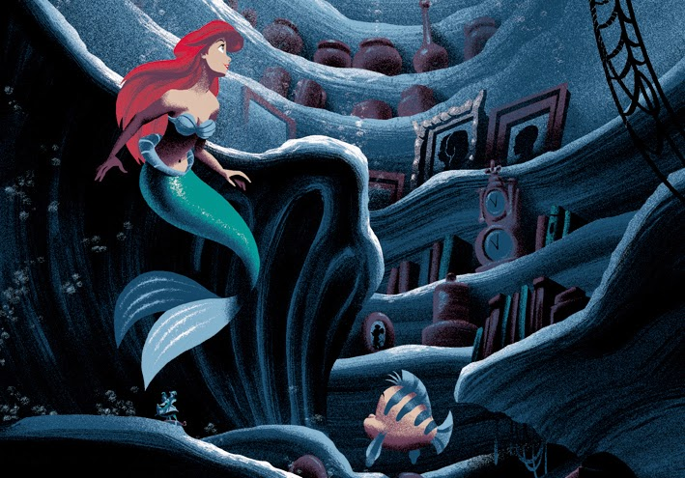

One night, she swam to the surface and saw a grand ship. Standing at the helm was a handsome young man, a prince. Ariel fell in love with the prince as soon as she saw him.
Suddenly, the waves became rough and the ship was tossed up and down until it finally tipped over, throwing everyone on board into the ocean. Ariel saw the prince was sinking in the water, unconscious, and she dove down to rescue him. She brought him up to the surface and swam to the shore, but he would not wake up.
Ariel gently lay the prince down on the beach and sang to him as the waves washed up around him. She stayed with him until the sun came up, singing a pure and beautiful melody.

Finally, the prince fluttered his eyes open. The little mermaid knew she couldn’t be seen by a human, so she quickly dove back into the water.

A man came down the beach looking for the prince, asking him what had happened. The prince couldn’t remember. Someone had saved his life, a young woman. He could still hear her beautiful singing voice in his head, but had never seen her face. The man was sure the prince had either been dreaming or had hurt his head, so he hurried him back to the castle to see a doctor.

Ariel was more determined than ever to return to the surface and find the prince that she was so in love with. Her best friend, a fish named Flounder, didn’t think it was a good idea – he was scared that something bad might happen. When she asked her father, King Triton, he forbade her from ever going to the surface again.She was determined to find a way to walk on land with the humans, to trade her fins for legs and feet. The crab Sebastian tried to convince her that life was much better under the sea, but she wouldn’t listen. Ariel went to see the witch, Ursula, to see if she could help.
Ursula agreed to help Ariel, but there was a catch. The witch would turn the little mermaid into a human, but Ariel would not be able to talk or sing – she would have no voice at all! Plus, Ariel would have to get the prince to kiss her before three days were up. If not, her soul would belong to Ursula, and she would be a prisoner forever in her garden of poor unfortunate souls. Despite the terrible conditions of the agreement.

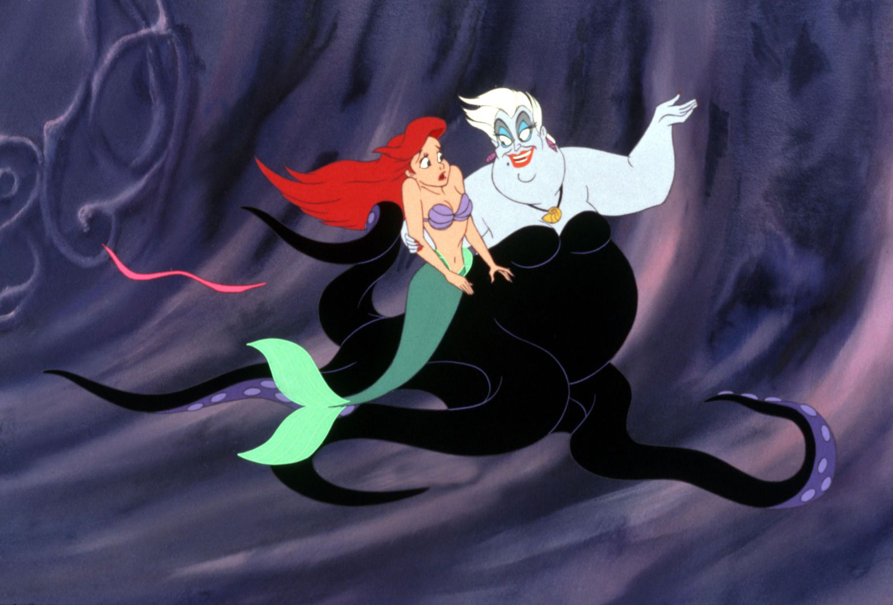

Suddenly, Ariel couldn’t breathe. Mermaids can breathe under water, but humans can’t. She tried to swim to the surface to breathe, but swimming was much harder with legs instead of fins. Finally, she made it to the surface, caught her breath, and started swimming to the shore.
When she finally reached the beach, Ariel was so tired that she immediately fell asleep.
The little mermaid was abruptly woken up by a dog licking her face on the beach just as the sun was coming up. It was the prince’s dog, and he quickly ran over to get the dog to stopped. Ariel was overjoyed to see him, but couldn’t say anything because the witch had aken her voice.
The prince saw that the poor girl had no clothes and couldn’t talk, so he gave her his coat and took her back to the castle.
Over the next two days at the castle, the prince taught Ariel the proper way to use a fork (not a dinglehopper, as she used to call it) and taught her to dance. She was getting worried that he wouldn’t kiss her in time, and her soul would one of Ursula’s prisoners forever.
That evening, the prince took Ariel out for a romantic ride in his rowboat. Her friends from the ocean knew they had to help get the prince to kiss her, so they sang a song to try to make him kiss the girl. The prince couldn’t understand what they were singing, of course, but he felt the urge to kiss Ariel. He leaned in, but just before he could kiss her, two of Ursula’s pet eels arrived and tipped the boat over. The moment was ruined, and time was almost up
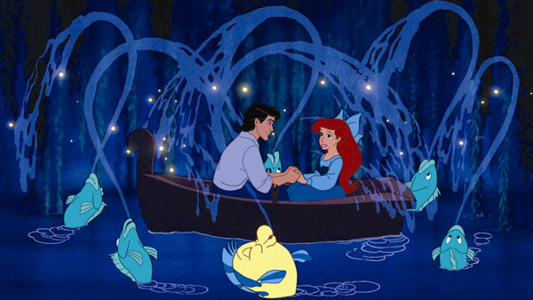
When Ariel came down for breakfast the next morning, on her third day, a mysterious stranger had the prince’s full attention. She was a beautiful woman with long, black hair. Ariel had no idea who it could be until the woman started to sing. It was Ariel’s own voice coming out of that woman! Ariel knew that it was really the witch Ursula disguised as a beautiful woman, but she was helpless and couldn’t say anything.
The prince was smitten. He was sure he had finally found the mysterious woman who had saved him from the ocean that horrible night and sang to him on the beach until he woke up. He immediately asked the witch to marry him – the wedding was to be at sunset that very day.
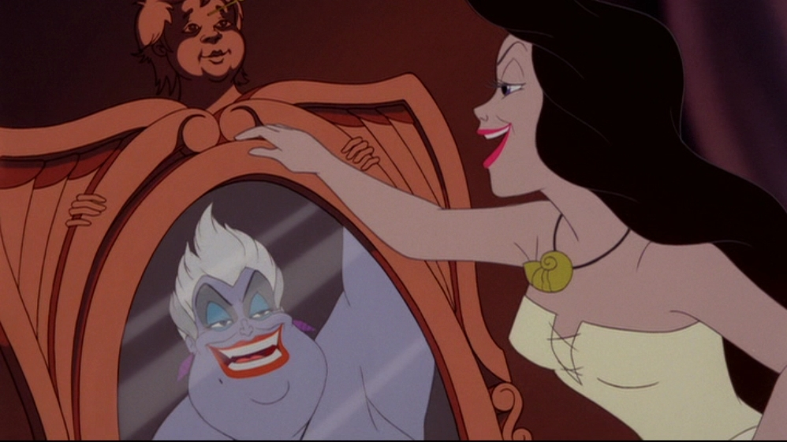
Fortunately, Sebastian the crab had sneaked into the kitchen and saw what was happening. He quickly ran back to the ocean to warn King Triton that his daughter was in danger.
Just before sunset, the prince’s ship sailed out to sea for a beautiful ocean wedding – except with the wrong bride! Ariel watched the ceremony begin, knowing that all hope was lost.
Suddenly, just before the final vows and the kiss, King Triton shot up out of the ocean and revealed the witch for who she really was. He used his magic trident to turn Ursula back into her true, ugly self and gave Ariel her voice back. The prince realized he had been tricked, and the woman he was in love with had been right in front of him the whole time.
The little mermaid finally got her kiss, even though the spell was already broken. She and the prince got married that very moment, and lived happily ever after.
