Weekly Home Learning Tasks
W/C: 04.05.20
What you need
‘What is Coronavirus?’ Story.  Old socks.  Old scraps of fabric, wrappers, buttons, glue, felt-tip pens, paint – whatever you can find. | Don’t forget to read everyday and do some exercise. Try the Joe Wicks  daily PE lesson or BBC supermovers  Monday  Get an adult to read you the ‘What is the Coronavirus?’ story. Talk about what it means and ask questions.  Make a sock puppet. Ask an adult for an old sock, or 2 and find things to make the face – buttons, scraps of fabric, glue, pens – whatever you can find. Get your family to help you.  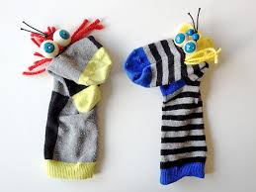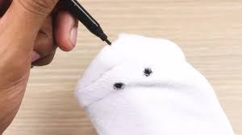  Day 1 Wellbeing Challenge – leave 3 happy notes to people in your home.  Sensory Music – Wake up  Twinkl – Listen and Do 1 – 5 word level  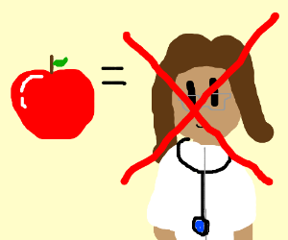  LCC: Science Question: Does an apple a day keep the doctor away: Discuss with your family. Write your final answer on a post it note and stick on a family notice board. Try eating an apple a day this week.
Large cardboard box. Pens, pencils, pain, scraps for collage, strong scissors, glue .  Paper, pens, coins. Ruler.  Home-made playdoh – see recipes. Plastic container or clingfilm.  Playdoh  Toys  Box or chair  Playdoh  Toys  Box  Chair  Dice  Counters | Tuesday  Make a stage to organise a puppet show. You will need a cardboard box . Get an adult to help you cut out the front and decorate the box to make scenery using pencils, pens, paint or collage.  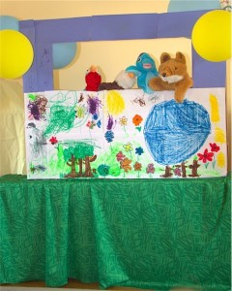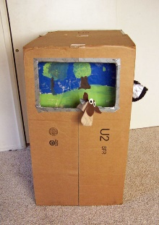  Day 2 Wellbeing Challenge – make a card for someone’s birthday or celebration.  Sensory Music – Calming  Twinkl – BBQ sequencing wh? Questions.  Wednesday  Arrange a puppet show for your family. Today you need to make your tickets – Talk to adults about when they could come to your show and make tickets to sell to them. How much are your tickets going to cost? (not too expensive or no-one will come) Don’t forget to put the time and the place on your ticket. Then, here’s the exciting part, you can sell them! Perhaps your adults will help you to name coins and practise counting them and giving change.  Day 3 Wellbeing Challenge – write down 5 things you are grateful for.  Sensory Music – Uplifting  Get an adult to help you make a Snakes and Ladders board game with paper or card. You need to use a ruler to draw 100 boxes and write numbers 1-100 in them in order from top left to bottom right. You can finish it tomorrow!  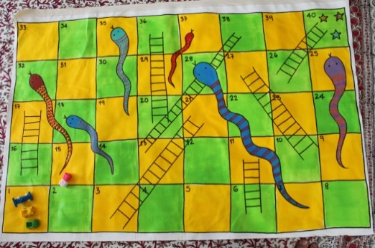  Thursday  Have your puppet show. Make sure everyone is sitting down comfortably and use your puppet to either tell a story, jokes or role play. Your show can be as funny as you like. Get the audience to join in by asking them questions or getting your puppet/s to talk to them. Ask someone to film you if you’re brave, then you can send the video to family who can’t come to your show – and your teacher!  Make playdoh today with an adult. Use one of the recipes provided. Use the playdoh to make the letters in your name. Talk about what you do with the doh – rolling, squashing, stretching. What words can you spell with the playdoh? When you’ve finished, wrap the doh up in clingfilm or put it in a sealed container, so you can use it again.  Finish your Snakes and Ladders board by drawing on snakes and ladders. Get an adult to help.  Day 4 Wellbeing Challenge – think about 5 jobs that people do. Pretend to do the jobs – can people guess the job?  Sensory Music –Uplifting Disney  Friday  Carry on using your puppet/s for story-telling and role-play. It’s good to practise and you can show your friends and teacher when you come back to school!  Use the playdoh from yesterday to practise making numbers. Practise counting and singing number rhymes like, 5 Little Speckled frogs or others you know. You might need to teach the adults!  Play Hide and Seek today with members of your family. Practise counting out loud? How long does it take to find someone? Which was the best hiding place? Perhaps you can play the game by hiding a toy and give clues to find it. Try to practise prepositions ‘on’, ‘under’, ‘in’, ‘next to’, ‘over’ with your family. Get them to ‘test’ you by using a teddy/toy and a chair or even your puppet stage.  Day 5 Wellbeing Challenge – What keeps you calm or makes you feel better? Tell your family.  Sensory Music – Calming Disney  Use dice and counters to play Snakes and Ladders with your own board. Remember to count on!  Science: What do I need to be healthy? Discuss with your family.  Draw pictures and create a poster.  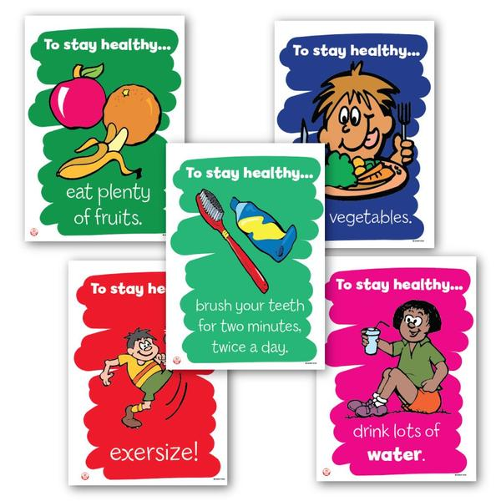  Try keeping healthy this week.

Tick off the activities as you go along.

