Weekly Home Learning Tasks
W/C: 4 .5. 20
What you need | Don’t forget to read every day and do some exercise.  Try the Joe Wicks daily PE lesson or BBC supermovers
 | Monday
A sheet of paper or card, a pen, scissors. | Maths | - Write out numbers 0-20 on paper or card, cut them up, then get an adult to mix them up. Practise putting the numbers in order. See how quickly you can do it – an adult can time you.  - Now make it harder. Turn the number cards upside down and mix them up again. Now you can play a memory game with a partner. Take turns turning numbers over and putting them in order. The first person has to find 0. If you turn over a number that is not in the correct order, you have to turn it back. The trick is to remember where the numbers are!  - Now try this with bigger numbers if you know them. Try 30, 50, or even 100!
Social story about social distancing.  *Reading book | Reading with an adult | - Read a book with an adult.  - Get an adult to read you the social story about social distancing. Talk about what it means and ask questions. What is a hero? Talk to an adult. Talk about your favourite super-heroes and why you like them. Talk about your own special powers, what are you good at?
Twinkl – Listen and Do 1 – 3 word level | Speaking & Listening | Twinkl – Listen and Do 1 – 3 word level
Cardboard tubes, glue, paint, felt-tips, scraps for sticking, scissors | Project- super-heroes  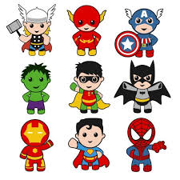  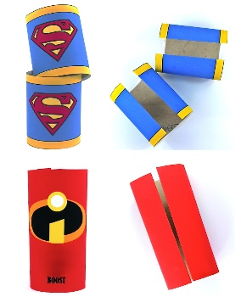 | This week you will be a super-hero. You will have super learning powers and super helping powers. Today you need to start making your super-hero costume, beginning with your cuffs. Decide what your super-hero name is going to be, then get an adult to help you make 2 cuffs for your arms by cutting open one side of the tube, before decorating your super-hero cuffs. Make sure you have the letter of your super-hero name on them!
Telephone or tablet | Day 6 Wellbeing Challenge | Call a relative or friend who you can’t see and have a chat with them. Perhaps an adult can help you see them if they are far away with a chat on Face-Time, Whatsapp or Skype.
Sensory music ‘wake up’ | Sensory Music | Sensory Music – Wake up
 | Tuesday
 | Maths  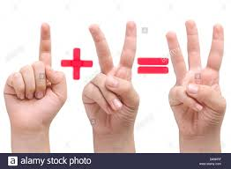 | Silent maths. Use your fingers today for numbers and symbols. You are going to be adding numbers to 10. Practise using your fingers to make a plus sign and equals. Ask a family member to play the game with you and test you on your number facts to 5 and 10. If that’s easy, go on to subtraction and take away from numbers to 10. Don’t forget the rule – no speaking! A thumbs up or down will tell you if you’re right! You can also practise testing your partner.
Reading book | Reading with an adult | Read a book with an adult.
Twinkl –Breakfast scene | Picture comprehension | Twinkl –wh? Questions. Breakfast scene
Cardboard or paper, pens, pencils, paint, scraps for collage, scissors, glue, strips of fabric for ties, tape measure. Egg box, paint. | Super heroes project  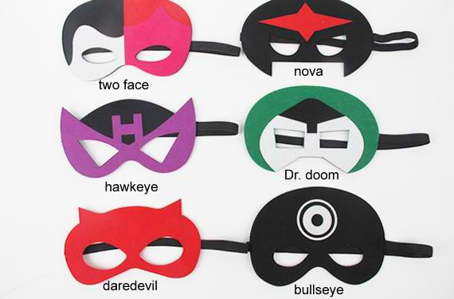  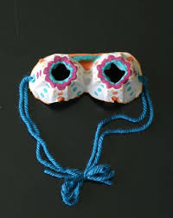 | Today you can choose. Do you want to make a super hero mask or super hero goggles?  Mask  - Ask an adult to help you draw the mask shape.  - Cut it out carefully, then decorate it – you can make it as exciting as you like.  - Finally, get an adult to measure your head with a tape measure, if you have one. Either make a paper strap to keep your mask on or use straps of fabric to tie at the back – you’ll need an adult to help with this!  Googles  - Cut a section of the egg carton, so you have a double egg section (with 2 egg spaces. Paint it and let it dry, before you cut and stick anything you want to decorate the goggles with.  - Finally, use the same method to make the back straps as for the mask.
Laptop  Tablet  Phone | ICT | Visit a virtual museum. Go online at https://artsandculture.google.com/ and visit the British Museum and hunt for 4 artefacts.
 | Day 7 Wellbeing Challenge | Write a letter to someone who you haven’t seen for a while. Tell them what you’ve been doing and ask them how they are. If you can, go with an adult to post the letter.
Sensory – calming | Sensory Music | Calming
 | Wednesday
 | Maths | Today play a ‘more or less’ game. You need to play with in a group of at least 3 for this. Person 1 writes a secret number on a piece of paper that is hidden from Person 2 who has to try to guess the number, while person 3 looks at the number and gives clues by calling out the words ‘more’ or ‘less’. The aim is to guess the secret number as quickly as possible. Each person takes it in turns to set the secret number, guess and give clues.
Reading book | Reading with an adult | Read a book with an adult.
Dressing up clothes. Paper, pencils, pens. | Super hero  Project | - Find the rest of your super hero outfit today. Will you wear a tracksuit? Can you use something as a cape? Perhaps you have some colourful socks.  - Once you are dressed, you are ready for some super hero learning.  - Now you need to write a super hero story.  - First you need to decide how the story starts and what the super hero does to save the day. Draw 3 pictures for the beginning, middle and end of your story, then write 3 sentences to go with the pictures.  - Now you’ve planned your story, you can perform it for your family. Maybe someone can video you and your super powers!
Paper and pencil | Day 8 Wellbeing Challenge | Look at favourite photos with your family. Talk about your memories and how they make you feel.
Sensory – uplifting | Sensory Music | Uplifting
 | Thursday
Card, paper, ruler, pens  Playdoh  Catalogues  Scissors  glue | Maths | Circle – describe a circle. Find things in your home that are circular and draw them in your book. If you have catalogues, cut and stick things that are circular in your book. How many circular things can you find? Count them and write the number in your book. If you have time, make circles with your playdoh.
Reading book | Reading with an adult | Read a book with an adult.
Sticks or straws, paper, card, pens, pencils, Twinkl super hero stick puppet guide.  Tape or glue.  Money | Super heroes Project | - Make some stick puppets today. Colour them in, cut them out, then stick them to sticks or straws.  - Now use your puppet stage from last week to have a super hero puppet show. Perform your super-hero story with your stick puppets. Perhaps you can sell tickets again. Ask adults to help you use real money and make sure you can name coins, count money and give the right change.
 | Day 9 Wellbeing Challenge | Think about the real super heroes in our world. Have you been clapping for the nhs? Talk to your family about people who help us. Play a game of charades with them and practise guessing the people who help us – eg, doctors, nurses, police, shop-keepers etc. There are lots!
Sensory – calming Disney | Sensory Music | Calming Disney

Parents – Try this useful website: www.fun2learn.com
Those children that usually access mathletics still need to do so.
Also continue to learn spellings from the year 2 list sent in week 1
https://login.mathletics.com/
For other Science and topic related activities for year 3 try the links below.
R.E: https://www.twinkl.co.uk/resource/t-re-357-ramadan-lantern-paper-craft
Science: https://www.science-sparks.com/easy-paper-spinners/

