Spelling shed spellings group 1
Please learn these spellings and put them into sentences in your exercise book if you cannot access spelling shed online.
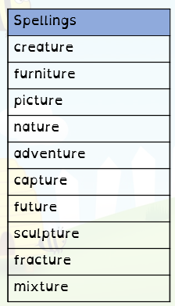
Spelling shed spellings group 2
Please learn these spellings and put them into sentences in your exercise book if you cannot access spelling shed online.
