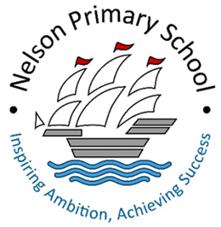
Weekly Home Learning Tasks
Year 1
W/C: 4.05.20
 | Monday | Tuesday | Wednesday | Thursday | Friday
Reading  Please look at the phonics timetable attached | Listen to your child read their reading book.  Read a story to your child and record on your read to me venture booklet.  Log onto You Tube for daily phonics lesson via link 1 below | Listen to your child read their reading book.  Read a story to your child and record on your read to me venture booklet.  Log onto You Tube for daily phonics lesson via link 1 below | Listen to your child read their reading book.  Read a story to your child and record on your read to me venture booklet.  Log onto You Tube for daily phonics lesson via link 1 below | Listen to your child read their reading book.  Read a story to your child and record on your read to me venture booklet.  Log onto You Tube for daily phonics lesson via link 1 below | Listen to your child read their reading book.  Read a story to your child and record on your read to me venture booklet.  Log onto You Tube for daily phonics lesson via link 1 below
Writing –  The magic pen; letter to my friend/teacher | Watch the Magic pen on YouTube (link 2). Discuss the story with your child. Ask; What would you do if you had this pen? How will you use it? What will you use it for? Where can you find a magic pen? Who would you share it with? What would it look like? | Watch the Magic pen with your child again. Help your child to write down all their ideas from previous discussion as a thought shower in their home learning book.  What would you do if you had this pen? How will you use it? What will you use it for? Where can you find a magic pen? Who would you share it with? What would it look like? | Get your child to design and draw their own magic pen. Label each part i.e. it might have a hook, a power button, a microphone, a light, a water spray button, wings etc. Use adjectives to describe i.e. Shiny gold hook. | Help your child to write a letter in first person to their teacher or a friend explaining what their magic pen looks like and what they can do with it. In the letter include how you are feeling being away from school, do you miss your friends? Teachers? What do you miss the most and why? Make sure to  Include; your address, friends address (Nelson Primary) and date. | Continue and finish off writing your letter. Ask your child to independently self-assess their writing using the following checklist:  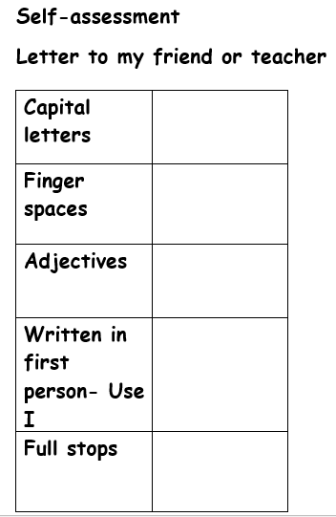
Maths | Help your child to complete the following task on mathletics:  Task:  1-30  Use link 3  Access daily maths lessons on BBC Bitesize (Link 4) | Help your child to complete the following task on mathletics:  Task:  1.Counting forwards 2.Counting backwards  Use link 3  Access daily maths lessons on BBC Bitesize (Link 4) | Help your child to complete the following task on mathletics:  Task:  Compare numbers to 50  Use link 3  Access daily maths lessons on BBC Bitesize (Link 4) | Help your child to complete the following task on mathletics:  Task:  1.Odd and Even numbers  2.Doubles and halves  Use link 3  Access daily maths lessons on BBC Bitesize (Link 4) | Help your child to complete the following task on mathletics:  Task:  Test  Use link 3  Access daily maths lessons on BBC Bitesize (Link 4)
L.C.C | Geography – Watch a video about different types of transports. (Link 5)  Work with your child to create a tally chart to record how many of each different transport they can see outside your house or when you go out for your daily exercise. Help your child to draw a table like the example on the transport tally attachment sheet in their home learning book.  Guide your child to write up a conclusion of their findings. Use the sentence starters on the transport tally attachment sheet to help them.  Science – Talk to your child about the different types of bird we see. Watch the video (link 6) Get your child to draw or make a bird. See ‘how to make a bird’ attachment sheet for ideas.  Challenge: Get your child to name the birds on the ‘Science Challenge’ attachment sheet. Get them to write some sentences about the similarities and differences between the birds in their home learning books.
P.E. | PE workout with Joe Wicks on you tube (Live at 9am or replay) | Log onto go noodle complete a workout of your choice.  Use link 7. | PE workout with Joe Wicks on you tube (Live at 9am or replay) | Log onto go noodle complete a workout of your choice.  Use link 7. | PE workout with Joe Wicks on you tube (Live at 9am or replay)
R.E.  Islam | Please see the ‘Religious Education’ and ‘Make a Sadaqah jar’ attachment sheets.
Music | Log onto online singing lesson on BBC Bitesize (link 8)
P.S.H.E | Watch and follow along with Cosmic Kids Zen Den on Youtube. (link 9)
Other activities | - Remember to read to your child daily and fill out your Read to Me booklet. If you need a new booklet, please ring the school and one can be sent out to you by post.  - Audible, a collection of stories, read aloud, are now available to access for free during the school closure. Google Audible Stories or go to https://stories.audible.com/start-listen . For Year 1 children look at ‘Littlest Listens’ but if you have children in older years then there will be something for them in ‘Elementary’ or ‘Tweens’. All stories are free to stream on your desktop, laptop, tablet or stream.

Links:
- RWI Phonics - https://www.youtube.com/channel/UCo7fbLgY2oA_cFCIg9GdxtQ
- CGI 3D Animated Short: "The Magic Pen" - by Edward Habib https://www.youtube.com/watch?v=7EP1dnaI2X8
- Mathletics - https://login.mathletics.com/
- BBC Bitesize maths - https://www.bbc.co.uk/bitesize/subjects/zjxhfg8
- Mode of transport for kids - https://www.youtube.com/watch?v=d0ySC2tzlZI
- Garden Bird Identification Video - UK Garden Birds ID and Names https://www.youtube.com/watch?v=wCngPMlOFok
- Go noodle - https://family.gonoodle.com/
- Singing - https://www.bbc.co.uk/bitesize/articles/z4fgrj6
- Cosmic Kids Zen Den: https://www.youtube.com/watch?v=JTb1XgZ3x-w

Tick off the activities as you go along.
There are other optional activities available on our school website under the home learning section.

