Weekly Home Learning Tasks
Year R
W/C: 04.5.20
 | Monday | Tuesday | Wednesday | Thursday | Friday
RWI  phonics | Follow the daily RWI lessons on Youtube. The details with times for lessons are in a separate document entitled YR wc 4.5.20 RWI phonics. Contact your class teacher if you need help accessing this resource.
Writing | Watch Julian is a Mermaid by Jessica Love  https://www.youtube.com/watch?v=95kovXm2hZA  Who are the characters in the story?  What does Julian want to be?  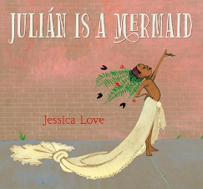 | What does Julian use to make his costume? Write a list.  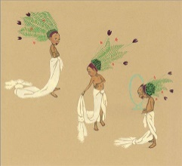 | Julian sees himself as a mermaid. Draw yourself. What would you like to become? | Draw your favourite part of the story and label/write a sentence. | B  A  N  K
Maths | Follow the online lessons on Oak National Academy Online Classroom.  https://www.thenational.academy/online-classroom/reception/maths/#subjects | Follow the online lessons on Oak National Academy Online Classroom. | Follow the online lessons on Oak National Academy Online Classroom. | Follow the online lessons on Oak National Academy Online Classroom.
Topic | This week investigate the question: ‘What do people around the world wear to celebrate?’  Watch: Traditional Celebration Clothes from Around the World  https://www.youtube.com/watch?v=ZkjAvPzXY8Y | - Draw a picture of what you wear for a special occasion. | Julian made his own costume for a carnival. Think about what you would like to wear.  Design your costume.  Please take a picture and upload to Eexat. | Label your design- what will you use? (think of junk from the recycling bin)  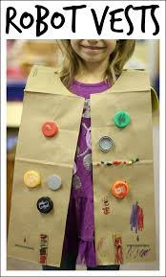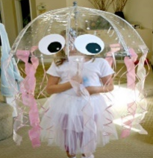 | H  O  L  I  D  A  Y
P.E. | Go to: Boogie Beebies Cleaning Crew  https://www.dailymotion.com/video/xxedly  Help clean your home while exercising! | The Body Coach is offering a live P.E. session daily at 9am. Google: The Body Coach PE with Joe to take part. The videos are saved on Youtube so can be done throughout the day. | Go to Go Noodle to have a dance.  https://family.gonoodle.com/activities/little-green-froggy  Can you do the dog, cat, moose dance?  Can you jump like a frog? | The Body Coach is offering a live P.E. session daily at 9am. Google: The Body Coach PE with Joe to take part. The videos are saved on Youtube so can be done throughout the day.
Music |  |  | Charanga  Login details have been sent to you.
P.S.H.E/  UW | Muslims around the world are celebrating Ramadan this month. https://www.bbc.co.uk/bitesize/clips/zm3b87h  Watch and talk about what you do that is the same or different? | They share a meal at the end of the day.  What do you like to eat? | Log onto PurpleMash and draw your favourite foods on a plate.  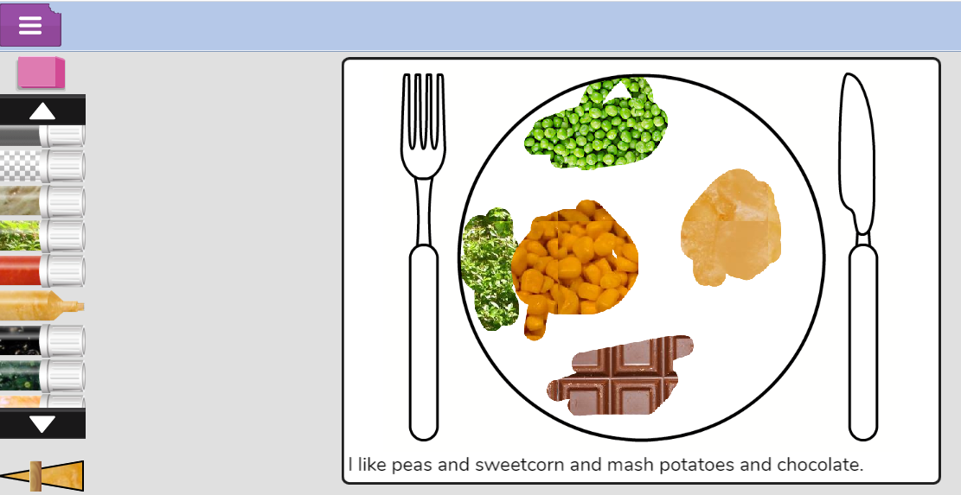 | Write a sentence about what you like and why.  Take a picture and upload to Eexat.
Other activities | - Remember to read to your child daily and fill out your Read to Me form. If you need a new form please ring the school and one can be sent out to you by post.  - Audible, a collection of stories, read aloud, are now available to access for free during the school closure. Google Audible Stories or go to https://stories.audible.com/start-listen . For Reception children look at ‘Littlest Listens’

Tick off the activities as you go along.
There are other optional activities available on our school website under the home learning section.

