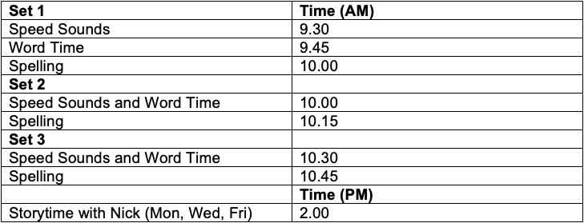
You can now access the speed Sounds, Word time and spelling lessons on Youtube. Click on the link provided and watch the lessons as they happen asking your child to take part. Encourage your child to repeat the sounds, read the words and spell the words. For the spelling part of the lesson your child will need a piece of paper and a pencil.
Please make sure you tune in to listen to the story read by Nick.
We have provided you with the time that these lessons will take place. Please can I ask that you ensure that your child is taking part in their daily Phonics lessons.
https://www.youtube.com/channel/UCo7fbLgY2oA_cFCIg9GdxtQ

