World War II - Y5 Project - Complete work in your exercise book or on PurpleMash
On Friday 8th May 2020 Britain will be commemorating the 75th anniversary of VE Day.

On the 8th May 1945 the Nazis surrendered and victory in Europe was declared. Sadly millions had died, but the millions who had been saved were able to celebrate the end of a six year world war and the VE Day parties went on for quite some time!

This home learning project will help you explore the impact of World War II on Britain.

To get started - Write down what you know, what you want to know on the KWL grid.
When you have finished your project you can write down what you have learnt.
Write a letter from the point of view of an evacuee to your family back in London.  Think about how you will convey feelings.  Are any of the feelings similar to the ones you are experiencing during quarantine? | A Day in the Life Of A 10-Year-Old Evacuee  https://www.youtube.com/watch?v=HFBlvWkNEKU  An Evacuees Adventure  https://www.youtube.com/watch?v=0SYDBJAwYCI&t=334s
Draw an evacuee.  Sketch an evacuee who is having to leave London. You may want to include their suitcase. Think about their facial expression. You can include thought and speech bubbles too. | 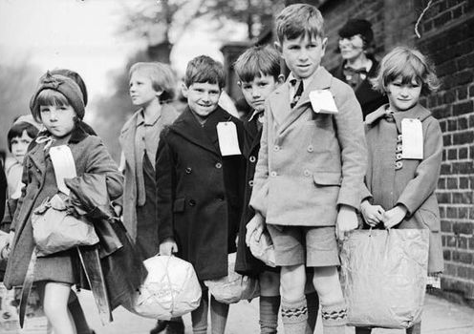
Design a poster.  Summarise key information relating to World War Two. Make your poster eye-catching.  You can look at British posters from the war to inspire you. | 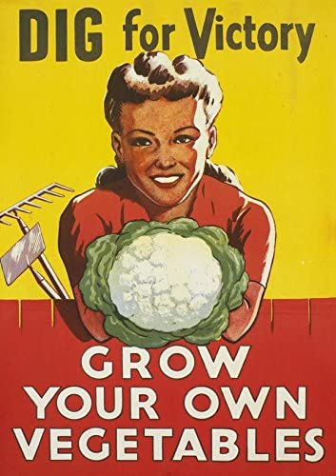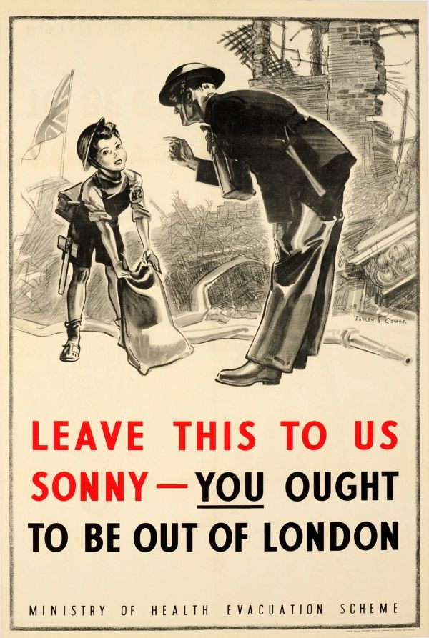
Write a newspaper report to announce that war has ended in 1945.
You should research some historical information to make your report authentic.
Listen to (There'll Be Bluebirds Over) The White Cliffs of Dover by Vera Lyn.  How do you think people felt when they listened to this song during WW2?  Dame Vera Lyn was born in East Ham! What other interesting facts can you find out about her?  Why do you think she was so popular? | 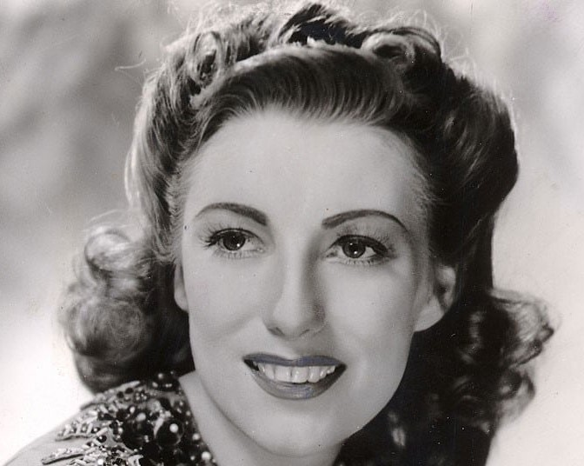  (There'll Be Bluebirds Over) The White Cliffs of Dover  https://www.youtube.com/watch?v=ovfQjR3iU-A
Listen to You'll Never Walk Alone - Captain Tom Moore, Michael Ball & The NHS Voices of Care Choir  Captain Tom Moore is a WW2 Veteran. He wanted to show support for all the NHS workers and those affected by COVOID-19.  What has Captain Moore been doing to raise money for charity?  What did he do during World War 2?  Write some interview questions that you could ask Captain Moore. | 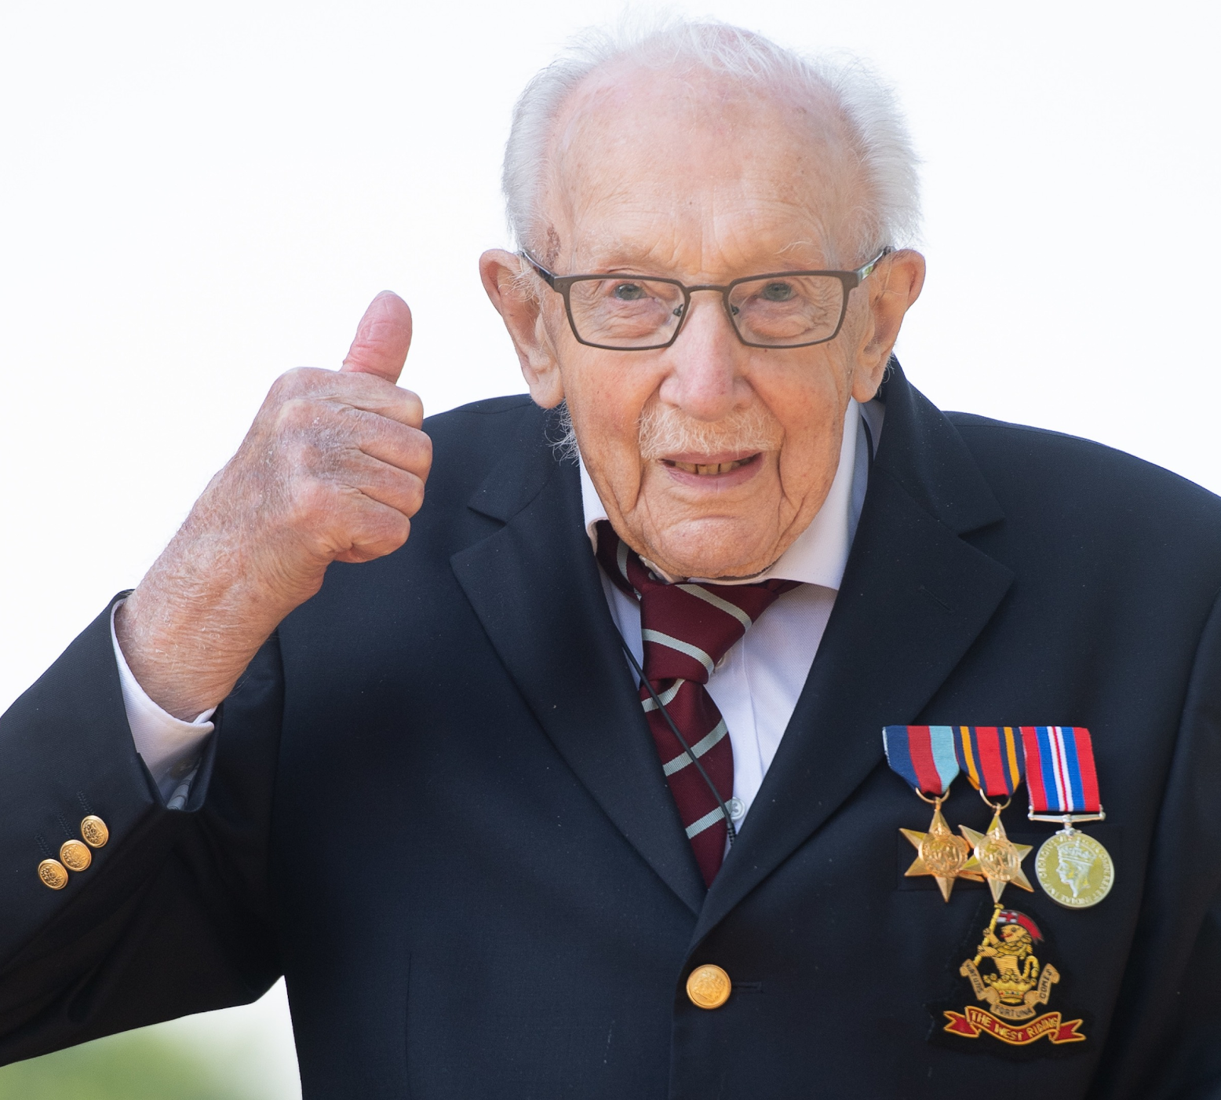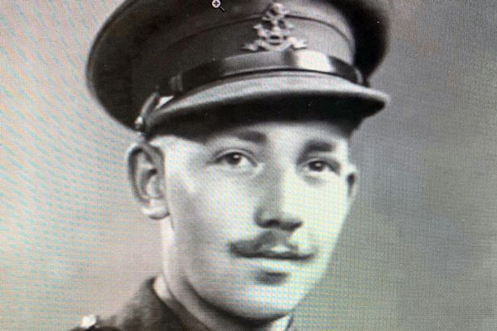  You'll Never Walk Alone  https://www.youtube.com/watch?v=LcouA_oWsnU
World War Two had a massive impact on the diet of ordinary British people.  Research into the rationing and shortages of food in Britain.  You can even try following one of the wartime recipes provided. | Rationing in the UK https://www.bbc.co.uk/teach/class-clips-video/history-ks2-rationing-in-the-uk/zbgby9q
Look at the images of Newham during the war. Can you find these places on a map?  If you live locally, you could walk to the site and take photographs.  How have these places changed? | 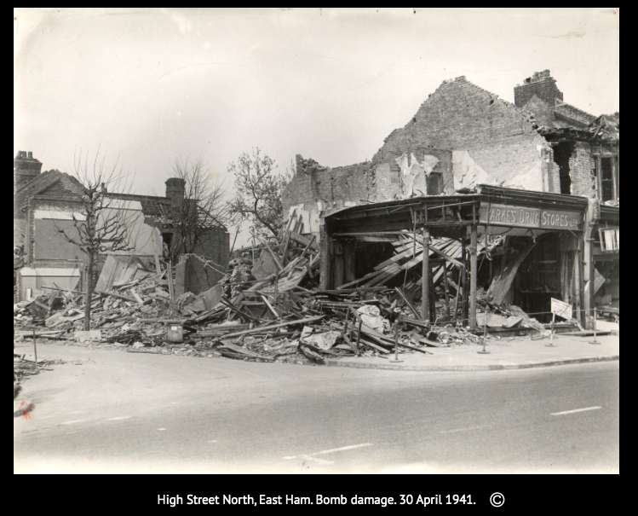
Design an Anderson shelter.  Use a range of materials to make an Anderson shelter. You could include objects that would be in your emergency pack for when the air raid siren sounds.  What else can you find out about Anderson shelters?  Where else did Londoners seek shelter during the blitz? Can you draw a picture? | 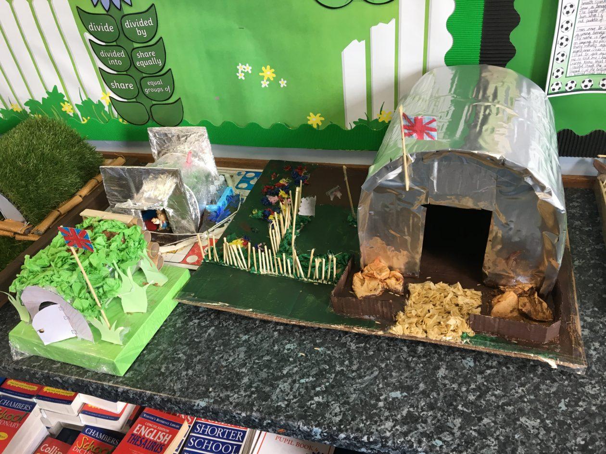
Create your own bunting.  Decorate your bunting to celebrate VE day. Here are some ideas of things that you could include in your designs:  - A soldier from WW2  - Union Flag  - A dove of peace  - Your message of thanks  - Your hero  Alternatively, you can use the template provided to design a VE day medal. | 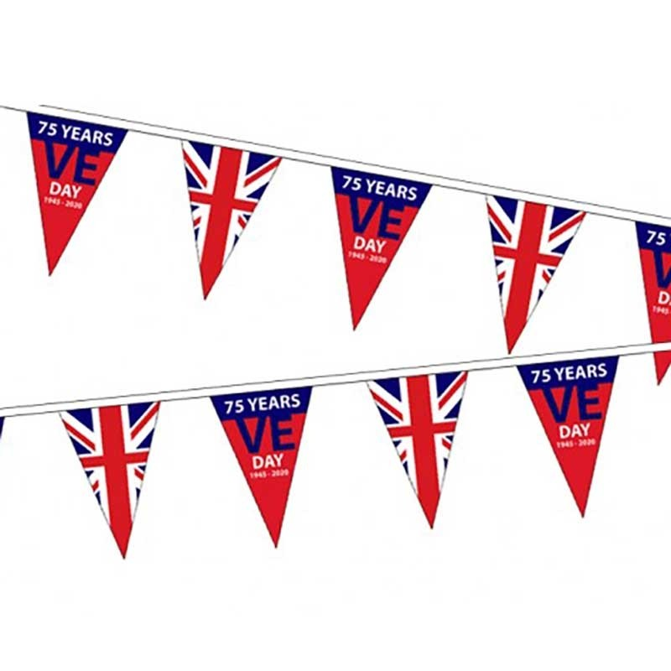
Video clips:  VE day:  https://www.bbc.co.uk/teach/class-clips-video/history-ks2-ve-day/z7xtmfr  What is VE Day? https://www.bbc.co.uk/newsround/48201749  WWII VE Day Song  https://www.bbc.co.uk/cbbc/watch/horrible-histories-songs-ve-day-song  Living through Air Raids  https://www.youtube.com/watch?v=4idj7fI6OZg  A Soldier's Daughter  https://www.youtube.com/watch?v=DuO1CYsPf_M | 